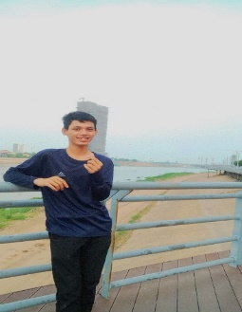CHHUN SEGHAK

Work experience in Phnom Penh as a web developer. And used to be a small team leader before. Used to love computer design until studying IT at PNC.

Work Experience

**Senior Digital Marketing Speciallst**

Activate media advertising

August 2018 to present I

Mplements cross-channnel marketing

and advertising campaigns. Responsible

for handing B2B and B2C client

marketing campaigns, from planning to

cptimization,

**Digital Marketing Specialist**

Serrawood art Collectors january 2012 to

August 2012

Developed and exxcuted digital marketing

Content strategies. Lncreased crganic site

Traffic by 79%

**Sales and Marketing Assistant**

Vandemar construction

July 2010 to december 2011

Worked on sales proposals and direct mail

Maketing campaigns. Coordinated trade

Show and events.

Skills and proficiencies

* Fluent in spanish and chinese
* Copywriting and copy editing
* Search engine Optimization (SEO) and

Search engine marketing (SEM)

Educational Background

De Loureigh University

Verston Bay

Master’s Degree in Digital Marketing 2017

Megna Cum laude

Croalstead institute of Technology

Bachelor’s Degree in Marketing 2010

Best Thesis; Anaryzing the role of Social

Media in Integrated Marteting

communications

Volunteer work

Volunteer social media coordinator

Fuzzbuzz Animal sheiter

2018 to present

Handies the sheker’s social media

Pages. Impiements online campaigns

To drive adoption rates up.